Shapes and Image Selection

Jason Kremhelmer

Southern New Hampshire University

CS:330: Comp Graphics and Visualization

Ronald Bishop

9/06/2024

Shapes and Image Selection

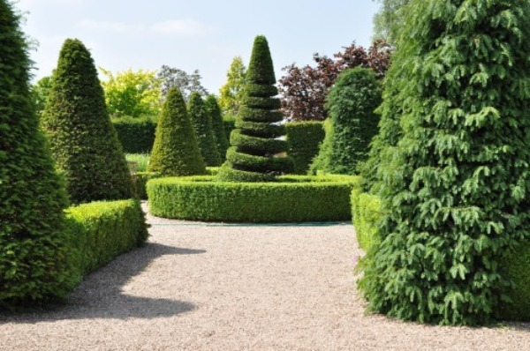

Some of the shapes that could be used to make this 2D image 3D are as follows:

* Torus
* Cone
* Box
* Tapered Cylinder

An object in this image that would require multiple shapes would be the center shrub. At first glance, a simple cone looks like it would suffice. However, due to the opening in the cone, you would need multiple tori’s adjusted along with an inverted cone on the top.

As for the object that could be removed, the trees in the background as they are not in focus. The only reason they are included in this image is that they were in the background when the photo was taken. Looking at the image, I can not see any objects that would be able to be combined to use a single shape.